 | Epsom & Ewell F.C.  5  v  Guildford City  Tuesday, 30th September 2014
For our League match this evening we welcome the players, officials and supporters of Guildford City, along with today's match officials and of course our own regular supporters.

Today’s opponents have been away from the Combined Counties League for a while but they enjoyed it so much, they’ve come back to renew old acquaintances! Well, maybe it wasn’t quite like that, but in attempting to bounce straight back up they have certainly found that life in our League is a bit tougher this time round. Having had no game since their 7-1 defeat at Horley Town last Tuesday, I wonder whether we will face the proverbial wounded tiger tonight!

Guildford were my tip for the title this season, and of course there is still a long way to go. However, I don’t imagine anyone expected they would be nearer the bottom than the top of the table at this stage. I’m sure that by season’s end, they’ll be in the right half.

Last time we were at High Road we said goodbye to our Manager Lyndon Buckwell and now this is truly Glyn’s team. His first match as Manager following the goalless draw with a committed and determined Frimley Green was at Knaphill, where we played really well, especially in the first half, scoring early and staying on top for large periods of the game in winning 4-1. Sean White scored his first two goals for the club, while Dale Marvell scored his 84th!

Following that we travelled to Westfield on Tuesday last and came back down to earth with a bump as we were beaten 4-0. Whilst slightly harsh score wise, we couldn’t argue with the result.

We then faced our third away match in eight days when making our first ever visit to Spelthorne Sports and after a slow start, we grew in confidence eventually wining 3-0 and in the process handing them their first home League defeat since 2nd March 2013. It was especially pleasing to see Dale Marvell scoring on his 300th appearance.

Please note that the club is now looking for sponsors. In particular, we are in need of match and match ball sponsors. Please take a look at the relevant section programme and please help your club; even if a couple of you pool together it all helps us and we are very grateful.

We’ve had a lot of away matches to start the season but it is now time to show our faces at High Road a bit more frequently. After today’s game we have a Saturday off due to our F.A. Vase exemption, but we then have four home matches in quick succession against Mole Valley SCR, Bedfont Sports, Knaphill in the League Cup and Ashford Town (Mx).

Please keep following the Salts. Glyn, the boys and the club value your support.

Enjoy the game!

Rich (Richard.c.lambert@gmail.com) on Twitter @EEFCOfficial

Cover photo this week by Gemma Jarman

Sean White volleys our opening goal in the 4-1 win at Knaphill


Cherry Red Records
Combined Counties League
Premier Division Table 2014/15
inc 27th September 2014 | P | W | D | L | F | A | Pts | GD | H | A
Cove | 11 | 10 | 1 | 0 | 27 | 12 | 31 | +15 | 7/3 | 15/11
Ashford Town (Mx) | 10 | 9 | 0 | 1 | 28 | 5 | 27 | +23 | 18/10 | 10/1
Molesey | 10 | 8 | 0 | 2 | 37 | 11 | 24 | +26 | 22/11 | 28/2
Camberley Town | 11 | 7 | 1 | 3 | 25 | 9 | 22 | +16 | 7/2 | 25/10
Spelthorne Sports | 10 | 7 | 1 | 2 | 19 | 12 | 22 | +7 | 11/11 | 3-0
Windsor | 10 | 6 | 2 | 2 | 24 | 10 | 20 | +14 | 3/1 | 11/4
Colliers Wood United | 12 | 6 | 1 | 5 | 22 | 20 | 19 | +2 | 4/4 | 2-3
Mole Valley SCR | 10 | 4 | 3 | 3 | 22 | 20 | 15 | +2 | 7/10 | 18/11
Epsom & Ewell | 10 | 4 | 2 | 4 | 19 | 15 | 14 | +4 | X | X
Hartley Wintney | 8 | 4 | 1 | 3 | 9 | 9 | 13 | 0 | 21/2 | 1-2
Frimley Green | 11 | 3 | 4 | 4 | 20 | 23 | 13 | -3 | 0-0 | 25/4
Bedfont Sports | 10 | 4 | 1 | 5 | 14 | 20 | 13 | -6 | 11/10 | 20/12
Horley Town | 11 | 3 | 3 | 5 | 22 | 25 | 12 | -3 | 2-2 | 6/4
Chertsey Town | 11 | 4 | 0 | 7 | 17 | 27 | 12 | -10 | 28/10 | 14/3
Raynes Park Vale | 8 | 3 | 2 | 3 | 10 | 11 | 11 | -1 | 0-1 | 27/12
Knaphill | 11 | 2 | 3 | 6 | 10 | 29 | 9 | -19 | 18/4 | 4-1
Westfield | 10 | 2 | 2 | 6 | 8 | 17 | 8 | -9 | 31/1 | 0-4
Farnham Town | 13 | 1 | 4 | 8 | 15 | 29 | 7 | -14 | 17/1 | 2-0
Guildford City | 10 | 2 | 1 | 7 | 15 | 31 | 7 | -16 | 30/9 | 29/11
Badshot Lea | 11 | 1 | 3 | 7 | 12 | 26 | 6 | -14 | 21/3 | 13/12
Hanworth Villa | 10 | 1 | 1 | 8 | 11 | 25 | 4 | -14 | 6/12 | 5-2

Lucky Day? – 30th September
Played 14 - Won 7 Drawn 1 Lost 6 - F 27 A 30 - PPG 1.57 - Above Average
Club record against Guildford City
Played 16 - Won 7 Drawn 1 Lost 8 - F 26 A 31 - PPG 1.38 - Average
Their last visit
Tuesday 23rd August 2011 - Lost 2-3 - Combined Counties League

Glyn Mandeville (written before Spelthorne game)
Good evening and welcome to everyone connected with Guildford City.

We turned up on Tuesday in great spirits after our victory over Knaphill; we welcomed back to the squad Karl Hough, James Taylor, Matt Tanton, and my Assistant Matt Smith, but lost Taylor Smith through work and mark Jarman through injury, so changes had to be made.

We started the match against Westfield well but had to make an unforced change to Sean White after an injury to his ankle (we hope he's ok).

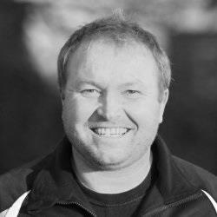
From then on we never really got going, our passing was poor and chances were few and far between, Westfield went one up and we had a chance to go into the break 1-1 but were unable to take our chance.

After a few words at half time we felt we need to up our work rate and make better choices with the ball, but the lads never really matched the heights of Saturday. Sometimes this happens in football; you don't mean for it to happen but it does.

I felt 4-0 was a bit harsh and I know the lads were gutted with the result. We have a very good and young team here and we want to get better and progress and this will happen if we stick together and work hard.

Manders

Anthony Panayi (written before Spelthorne game)
Evening all!

Starting off with a positive, a brilliant away win at Knaphill last Saturday with lots of goals and a good team performance! Unfortunately we never really got going against Westfield on Tuesday evening, ending our resilience of late.

A special mention to Sean White who scored two goals last weekend. Sean is a young lad with loads of potential, which all the boys have been very impressed with since making his step up from the Reserves in pre-season.

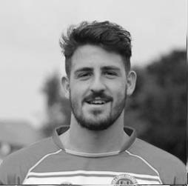
We are very much looking forward to our next two fixtures, Spelthorne Sports and Guildford City. The Spelthorne game will have an added motivation for us as we lost to them on penalties last season in the Southern Combination Cup so we are hoping to set the record straight.

Lastly a massive thank you to our club’s Physio Ken Jones, who left the club last week. Ken’s commitment and personality is something the club will miss and we wish him well in his next adventure.

All that’s left now is to hope we get three points from tonight’s game.

Thank you for your support.

COME ON YOU SALTS!

Ant

Results and Fixtures
F.A. Cup First Qualifying Round – Saturday 13th September
Knaphill | 1-2 | Fleet Town
Ramsgate | 1-2 | Raynes Park Vale
Combined Counties League – Saturday 13th September
Ashford Town (Mx) | 3-0 | Guildford City
Camberley Town | 2-1 | Colliers Wood United
Chertsey Town | 3-2 | Badshot Lea
Cove | 2-1 | Molesey
Epsom & Ewell | 0-0 | Frimley Green
Farnham Town | 2-1 | Hanworth Villa
Hartley Wintney | 2-3 | Spelthorne Sports
Horley Town | 0-1 | Bedfont Sports
Windsor | 6-0 | Mole Valley SCR
Combined Counties League Cup First Round – Tuesday 16th September
Bedfont Sports | 3-1 | Staines Lammas
Frimley Green | 2-1 | AFC Croydon Athletic
Raynes Park Vale | 0-5+ | Spelthorne Sports
Sandhurst Town | 1-5 | Horley Town
Combined Counties League – Tuesday 16th September
Farnham Town | 0-0 | Mole Valley SCR
Combined Counties League – Wednesday 17th September
Chertsey Town | 0-2 | Knaphill
Guildford City | 3-2 | Badshot Lea
Combined Counties League – Saturday 20th September
Badshot Lea | 1-1 | Colliers Wood United
Cove | 2-0 | Badshot Lea
Guildford City | 2-2 | Windsor
Hanworth Villa | 0-2 | Frimley Green
Horley Town | 0-4 | Ashford Town (Mx)
Knaphill | 1-4 | Epsom & Ewell
Molesey | 1-2 | Hartley Wintney
Raynes Park Vale | 1-1 | Farnham Town
Spelthorne Sports | 0-0 | Camberley Town
Westfield | 1-3 | Chertsey Town
Combined Counties League – Tuesday 23rd September
Farnham Town | 2-6 | Cove
Frimley Green | 2-1 | Badshot Lea
Horley Town | 7-1 | Guildford City
Knaphill | 0-8 | Molesey
Westfield | 4-0 | Epsom & Ewell
Windsor | 2-1 | Raynes Park Vale
Combined Counties League – Wednesday 24th September
Colliers Wood United | 2-1 | Spelthorne Sports
Results and Fixtures
F.A. Cup Second Qualifying Round – Saturday 27th September
Billericay Town | 2-1 | Raynes Park Vale
Combined Counties League – Saturday 27th September
Ashford Town (Mx) | 3-1 | Farnham Town
Chertsey Town | 2-3 | Cove
Colliers Wood United | 2-0 | Westfield
Frimley Green | 2-4 | Molesey
Hartley Wintney | 0-2 | Camberley Town
Knaphill | 3-1 | Hanworth Villa
Mole Valley SCR | 3-3 | Badshot Lea
Spelthorne Sports | 0-3 | Epsom & Ewell
Windsor | 5-1 | Horley Town
Combined Counties League Cup Second Round – Tuesday 30th September
Ashford Town (Mx) | V | CB Hounslow United
Combined Counties League – Tuesday 30th September
Epsom & Ewell | V | Guildford City
Hanworth Villa | V | Raynes Park Vale
Westfield | V | Badshot Lea
Combined Counties League Cup First Round – Wednesday 1st October
Chertsey Town | V | Hartley Wintney
Combined Counties League Cup Second Round – Wednesday 1st October
Colliers Wood United | V | Bedfont & Feltham
F.A. Vase Second Qualifying Round – Saturday 4th October
Colliers Wood United | V | Shoreham
Cray Valley (PM) | V | Horley Town
Farnham Town | V | Milton United
Flackwell Heath | V | Frimley Green
Highworth Town | V | Hartley Wintney
Molesey | V | Greenwich Borough
Raynes Park Vale | V | Epsom Athletic
Rothwell Corinthians | V | Bedfont Sports
Spelthorne Sports | V | Risborough Rangers
Windsor | V | Binfield
Woodley Town | V | Knaphill
Combined Counties League – Saturday 4th October
Ashford Town (Mx) | V | Chertsey Town
Cove | V | Guildford City
Combined Counties League – Tuesday 7th October
Bedfont Sports | V | Knaphill
Camberley Town | V | Horley Town
Epsom & Ewell | V | Mole Valley SCR

From behind the goal
Epsom & Ewell 0-0 Frimley Green – Combined Counties League
Saturday 13th September 2014

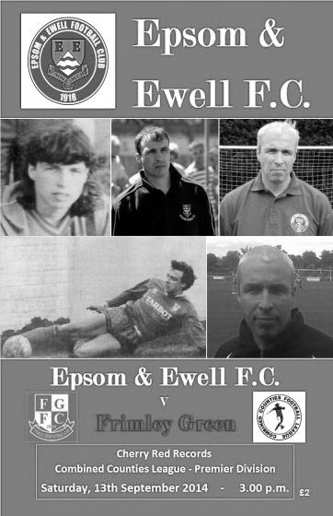
Salts misfire as Lyndon departs

The Salts failed to come up with a win as they said goodbye to long-serving Manager Lyndon Buckwell, but they came mighty close to scoring against a competent and determined Frimley Green defence and had to be content with a goalless draw, that rarest of results for our team these days. In fact it was our first home League goalless draw since April 2010 when Dorking held us at Merland Rise, but I digress!

Lyndon chose to leave all the duties to our new Manager Glynn Mandeville and missing the injured Ali Dewar and Harry Hoadley we took the field with four recognised centre halves but there was still plenty of firepower on show with Taylor Smith and Kyle Hough paired up front and Sam Robinson just behind them.

It was Robinson who had the first opportunity in the third minute when he struck a low free kick but visiting keeper Jamie Cunningham was able to get the ball away for a corner. Taylor Smith had a header over the bar from a Dan Dean cross that in fairness was just too high for him, before we had a scare in the twelfth minute when a Frimley ball in to the box was cleared straight back to the attacker and his shot was well blocked by Michael Eacott who would not have another save to make until the final quarter of an hour.

Cunningham however, was to have a much busier day and in the twentieth minute he made contact with Smith, conceding a penalty in the process. However, he became a member of an elite club when diving low to his right to save a Kyle Hough penalty, turning the ball out for a corner. From the corner we were unfortunate again when Smith met the ball with a great downward header but the ball bounced down and back up over the crossbar, dropping onto the stanchion just behind.

After 24 minutes we nearly scored again when Hough struck his shot goalwards only to see the ball cannon up and over the bar off a defender. You began to wonder at that point whether it was going to be one of those days and as the half closed, the game became more even with much of the play confined to midfield.

The second half opened with the first chance falling to Hough after being set up by Robinson, but with the goal to aim at, his low shot lacked power and was saved by Cunningham, low to his left. After 51 minutes Robinson was unfortunate not to score himself when a deep left wing cross was met by his looping header but again the keeper was able to touch the ball over for a corner.

The half continued with further chances. Hough sent in a cross after 59 minutes which almost went in at the far post, missing it by less than a foot. Smith got through a few

minutes later but he was wide and his shot also went across goal. Still it looked like we would get through and we nearly scored from a corner when George Murphy met the ball with force but was unable to keep the ball down.

Smith had picked up a knock earlier in the game and he was replaced by Mark Jarman while Dale Marvell replaced Lionel Mutima after 74 minutes as we reverted from a 3-5-2 to a 4-4-2 formation. Eacott was required to make a good save after 75 minutes while Murphy made a good block of a shot from a loose ball soon after this.

With the clock on 80 minutes Robinson again turned provider after drawing a defender and setting up Jarman who had time and space but his low shot was deflected out for another corner by Cunningham's outstretched leg. He had a scare three minutes later when dropping a deep cross from out on the right but was able to recover to catch the ball before the nearby James Taylor was able to reach it.

As time wound down Robinson let fly from fully thirty yards and his powerful shot was parried away. Had it been a couple of feet further away it would have been right in the top corner but that sort of summed up our day. Close but no cigar!

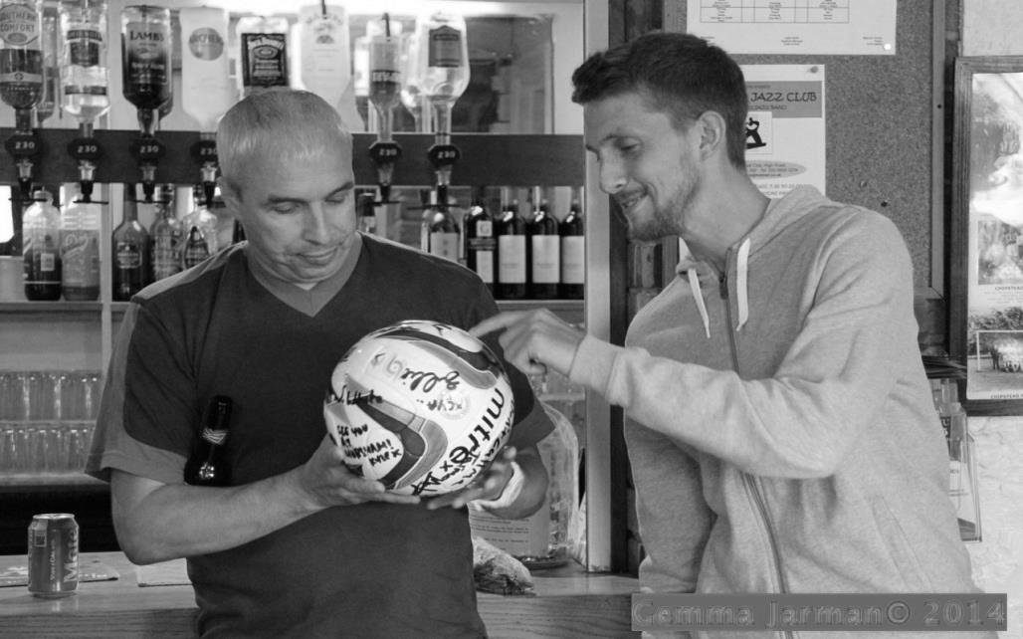
But the match was never going to be the main story this day, and a draw and a clean sheet for Lyndon to go out was a vast improvement on how our last Manager Paul Pritchard bowed out; beaten 6-1 at home by Egham! Now the baton passes to Glyn Mandeville and we all go again next Saturday at Knaphill.

Team: Michael Eacott, Lionel Mutima, Matt Tanton, James Taylor, Anthony Panayi ©, George Murphy, Dan Dean, Matt Farrell, Taylor Smith, Kyle Hough, Sam Robinson

Subs: Mark Jarman for Smith (70), Dale Marvell for Mutima (74)

Lyndon receives a Match ball signed by the players after the game
from currently injured Club Captain Sam Currie

From behind the goal
Knaphill 1-4 Epsom & Ewell – Combined Counties League
Saturday 20th September 2014

New Manager Syndrome works in our favour!

Glyn Mandeville's first game in charge ended exactly the same way of his predecessor Lyndon Buckwell; with a three goal win away from home.

As a rule, whenever we face teams that have new Managers we struggle, most recently at Badshot Lea earlier this year, but on countless other occasions in the past, so it was nice to see the tables turned for a change.

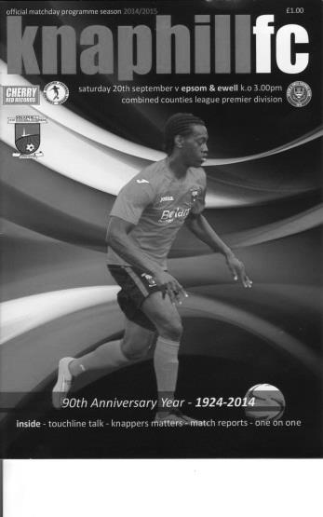
What made this result even more impressive was that it was achieved with a number of regular faces away. Kyle Hough, Anthony Panayi, Ben Hayward, Matt Tanton and James Taylor were all missing from the draw with Frimley Green for a number of reasons and so George Murphy took over the Captain's armband for the day. In addition Glyn only had four substitutes on the bench, of which he was one. Two others had just signed for us and would show potential in their late cameos.

By then the game was over as we got off to a flyer and maintained an excellent level throughout the first half. A good spell of pressure right from the start ended with the ball reaching Matt Farrell. His clipped ball across the penalty area was met by a volley from Sean White that went in to the net with just one minute and forty seven seconds on the clock.

It was Sean's first goal for the club although it must be said that there was an element of fortune about the strike as he didn't quite catch the ball fully, and it sliced up and over the unfortunate keeper Shelley. However, there was no doubt about the second. Sam Robinson won the ball in midfield and set Taylor Smith off down the left. He cut in and tried to lift the ball over the keeper, who got a hand to it, but the loose ball fell to White again and from twelve yards he showed great technique to keep the ball down, firing it into the roof of the net after just nine minutes.

On the quarter hour mark Farrell again won the ball and set up Mark Jarman, making his first start of the season. He cut in and struck the ball well enough, but the ball took a slight deflection and narrowly missed the keeper's left hand post. From the corner Shelley again got a hand to the ball but this time it fell to Murphy who volleyed the ball just over the bar.

We were rampant at this stage with the hosts being restricted to a number of long range efforts that mostly cleared Michael Eacott's bar by some distance. This was a pity for the home team who showed some good touches on an excellent Redding Way surface but either they were too impatient or we were defending too well to allow them any closer. It was probably a combination of both.

The game became more even as we approached the break with our boys happy to play on the counter, which they were doing excellently. From one such move we extended our lead after Farrell again turned provider to Jarman down the right wing. He beat his man before

sending in a deep cross which Smith, having pulled away from his man, was able to head the ball powerfully into the net.

As we kicked off for the second period, the question was whether we could maintain the level provided in our best forty five of the season so far. Dale Marvell felt it could be bettered and had a try after 49 minutes with his right foot. The effort was blocked but fell back to him and he lashed it into the net from twenty five yards for our fourth goal. (see picture) This was his eighty-fourth goal for the club and although he has hit a few beauties, I doubt whether he has hit one so sweetly with his left foot before!
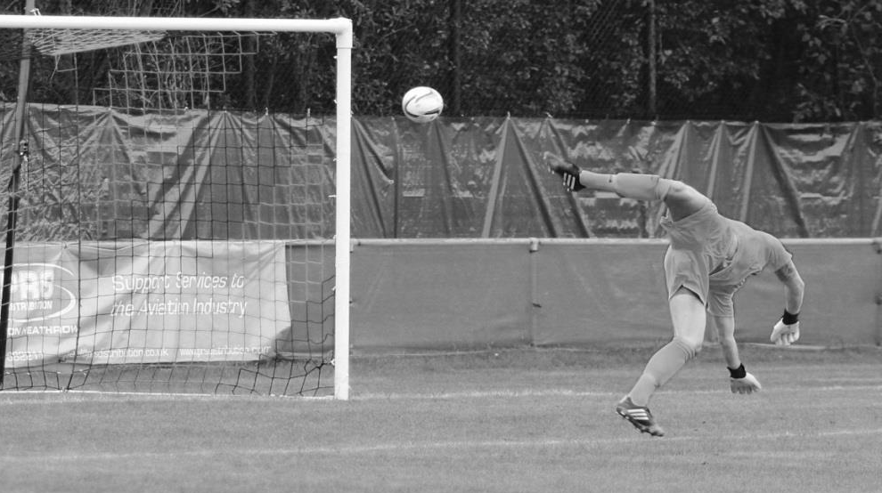
A four goal lead was harsh on the hosts. They had started poorly but had started to push us back. In fact they nearly reduced the arrears when Scott Costello saw his low shot tipped onto the post by Eacott after 53 minutes. The game was still one of attack and counter attack, although we were beginning to invite them on a bit too much and they reduced the arrears after 63 minutes when from good work on their left wing, the ball reached the substitute Emmanuel Oloroyde who struck low, just inside Eacott's right hand post.

They probably felt they could get back into the game when Robinson rather foolishly got himself sent off after receiving a warning after 61, a yellow after 70 and then sticking out a leg for a blatant foul just five minutes later. However, we actually improved after this and had two good chances to extend our lead. After 88 minutes debutant Matthew Ferdinando set our other substitute Ollie Shaw down the right but his low cross to the waiting Smith was blocked at the last moment by a defender. As time expired Shaw dealt with a bouncing ball better than the defender but his shot went into the grateful Shelley's arms.

So it's "Under new Management" but "Business as Usual" as the Salts now find themselves up to twelfth and with games in hand over the teams above them, and a trip to Westfield next gives us a chance to get back into the top ten.

Team: Michael Eacott, Lionel Mutima, Luke Gaffney, George Murphy, Dan Dean, Sean White, Matt Farrell, Sam Robinson, Mark Jarman, Taylor Smith, Dale Marvell

Subs: Ollie Shaw for Jarman (83), Matthew Ferdinando for White (88)

Club Records - 30th September
Date | Day | Competition |  | Opponents |  | Scorers
30/09/33 | Sat | F.A. Cup 1q | H | Nunhead | 3-0 | L.Marlow (3)
30/09/50 | Sat | Corinthian League | H | Maidenhead United | 3-2 | B.Musto (2), T.Wright
30/09/61 | Sat | Amateur Cup Preliminary Round | H | Petter Sports | 5-3 | L.Pritchard, R.Dowse, B.Robinson, J.Punter, R.Salter
30/09/67 | Sat | Amateur Cup Preliminary Round rep | A | Ulysses | 3-1 | J.Eales, C.Kelly, T.Stafford
30/09/71 | Thur | Southern Combination Cup 1 | H | Aldershot Services | 1-4 | o.g.
30/09/72 | Sat | Athenian League 2 | H | Ware | 0-2
30/09/78 | Sat | Isthmian League 1 | A | Ware | 1-1 | T.Tuite
30/09/80 | Tue | Isthmian League 1 | A | Met Police | 2-0 | T.Tuite, J.Hunn (pen)
30/09/89 | Sat | Isthmian League 2s | H | Camberley Town | 1-0 | G.Smith
30/09/97 | Tue | Isthmian League 3 | A | Dorking | 3-4 | A.Nimmo (2), M.Owen
30/09/00 | Sat | F.A. Cup 2q | A | Horsham | 1-5 | B.Forey
30/09/03 | Tue | Isthmian League 1s | A | Whyteleafe | 2-5 | S.Huckle, J.Rogers
30/09/06 | Sat | Combined Counties Premier Division | A | Chertsey Town | 0-2
30/09/08 | Tue | Combined Counties Premier Division | H | Colliers Wood United | 2-1 | G.McLaughlin, o.g.
Historical Decades
90 years ago – Epsom Town
27/09/24 | Sat | Surrey Senior League | A | Addlestone | 2-0 | C.Aldridge, S.Bristow (pen)
80 years ago – Epsom F.C.
29/09/34 | Sat | F.A. Cup 1q | A | Streatham Town | 2-2 | T.Dunne, M.Wiggins
70 years ago – War time Epsom Town
30/09/44 | Sat | Friendly | H | Royal Artillery (Woolwich) | 0-3
60 years ago – Epsom F.C.
29/09/54 | Wed | F.A. Cup 1q replay | H | Whitstable Town | 1-4 | B.Avis
50 years ago – Epsom & Ewell
26/09/64 | Sat | Athenian League 1 | A | Harrow Town | 2-3 | B.Mackay, T.Higgins
40 years ago – Epsom & Ewell
28/09/74 | Sat | Surrey Senior League | A | Cobham | 4-1 | D.Ritman (pen), T.Tuite, J.Eales, T.Lee (pen)
30 years ago – Epsom & Ewell
29/09/84 | Sat | F.A. Cup 2q | A | Eastbourne Town | 4-2 | T.Tuite (3), C.Miles (pen)
20 years ago – Epsom & Ewell
01/10/94 | Sat | F.A. Vase  Preliminary Round | A | Cobham | 0-0
10 years ago – Epsom & Ewell
25/09/04 | Sat | Associate Members Trophy Group Match | A | Chertsey Town | 0-2

History Corner – 30th September
90 years ago this week there were 1,200 spectators at Addlestone’s Green Lane ground to witness our 2-0 win. Charlie Aldridge and Sid Bristow with a penalty were our scorers as we remained unbeaten in our first Surrey Senior League campaign.

81 years ago today we continued our famous F.A. Cup run with a comfortable home win over Isthmian League Nunhead. A Leslie Marlow hat trick disposed of them as we continued our path to the First Round Proper for the only time in our history. (see programme right)

80 years ago this week we were held to a 2-2 draw by Streatham Town but the replay would prove to be the strangest of games as we trailed 3-0 after 20 minutes at West Street only to turn the tie around to win 7-4.
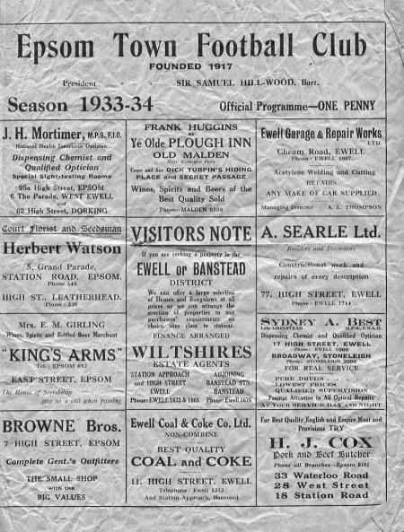
60 years ago this week we faced an F.A. Cup replay with Whitstable Town. Having recorded our first goalless draw for 17 years in the first match, it was thought that this would be a tight replay, but a Bobby Avis goal was nowhere near enough as our Kent opponents progressed at a canter.

47 years ago today we travelled to Ulysses who played in Motspur Park. This Amateur Cup tie was won 3-1 and one of the goals came from Chris Kelly, an eighteen year old who would go on to better things. Another very famous player who started his career here by the name of Larry Pritchard also scored for us this day, exactly six years earlier!

30 years ago this week we travelled to the Saffrons, a ground we used to visit regularly in the fifties and sixties, for an F.A. Cup tie, and in front of approaching 500 spectators the Sussex League team took an early 2-0 lead. Fortunately, we were able to fight back and win 4-2 with Tommy Tuite scoring a hat trick. This remains the last time we won an F.A. Cup second qualifying round tie. And I remember it well!

14 years ago today we were playing an F.A. Cup tie at Queen Street, the old and much missed ground of Horsham. We even took an early lead through Ben Forey but trailed 3-1 not long after and when Andy Nimmo missed a penalty we knew it wasn’t our day, losing 5-1 in the end.

11 years ago today we were enduring a torrid season, but there was a glimmer of light at Whyteleafe as we had played well and led 2-1 at the half with goals from Simon Huckle and Joel Rogers. Unfortunately Simon Hatton then received his marching orders for kicking out and we collapsed to a 2-5 defeat. It was that sort of season!

10 years ago this week many supporters completed a sponsored walk to Chertsey Town. In total nearly £2,500 was raised but the walk, I can confirm was a painful one. However, the players hardly registered a shot on target as we lost 2-0.

Dale Marvell – 300 up!
Congratulations to Dale Marvell who played his 300th match for the club on Saturday at Spelthorne Sports.

When Dale reached his 250th appearance in August 2012, I wrote at the time that he was a member of an elite group of just seventeen players. It is testament to the loyalty we have at this club that this number is now twenty, having been joined by Kyle Hough, Ben Hayward and Jamie Hatfield.

However, none of those players have yet reached the 300 mark and Dale becomes just the twelfth person in Club History to reach that figure, and our first since goalkeeper Dave Hyatt on 13th November 2001.

Dale joined us for the first time from Kingstonian and made his debut way back on 15th January 2000 at the age of 19 when Adrian Hill introduced him as a substitute for Sean Grant in our 2-1 win at Merland Rise. He scored his first goal for the club two months later on 25th March in a 2-1 home win over Camberley Town.

If I’m honest, the youngster didn’t exactly set the pitch alight at first. In fact a local paper accidentally called him Pale Marvell, which was quite funny at the time!

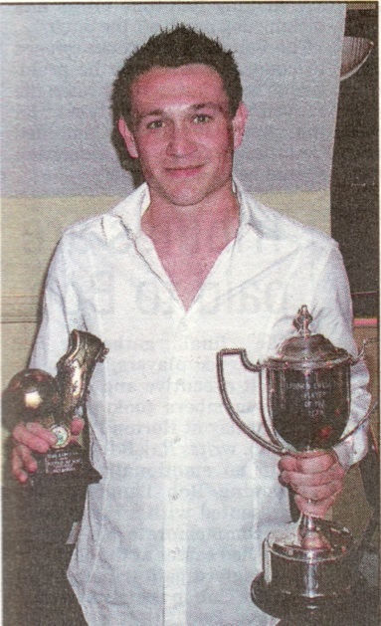
He was regularly involved in 2000/01, albeit mostly from the bench, and after a few games at the start of 2001/02 he left the club to try his luck with Sutton United and Carshalton Athletic, where he had a fair bit of success.

He returned again under the Management of Ray Purvis in 2005 and was clearly a better player. He became club Captain in November of that year and remained despite the sacking of Purvis in January 2006, scoring twice against Brook House on his 100th appearance on 29th March 2006.

In August of 2006 he became the first player to score a hat trick in a match that we failed to win (4-4 v Raynes Park Vale) since 1966 and following the departure of the next Manager Paul Pritchard, he became an integral part of Lyndon Buckwell’s plans throughout the season, almost single-handedly keeping us from a relegation position.

He departed the next season for a brief spell at Corinthian Casuals, playing against us in the Dave Wilson Trophy before moving to Banstead Athletic where he also played against us that December. However, by the second game of the 2008/09 season he was back again, setting up Robbie Burns for a header at Guildford City within a minute of the game starting. He also scored his second hat trick for the club in a 3-2 win over North Greenford United on 19th January 2009 and made his 200th appearance on 21st April in a 2-2 draw at Chessington & Hook.

Following our good Vase run in 2009/10 he left to play for Merstham, although he reappeared briefly at the end of the season to help us out once the Moatside club had finished their fixtures. The next season he started at Merstham but then returned again in March, playing in our final eleven fixtures.

Last season he left to spend the season with Egham Town but returned the following season when he made a further 43 appearances, including his 250th. I wrote at the time that maybe he would stay a little longer, but despite making an appearance in our opening match of 2013/14 at Alton, he was off again, spending a bit of time at Molesey and then Chessington & Hook United, where he scored against us once again in a 2-2 draw in April.

He is now having his seventh separate spell with us at the age of 34 and provides us with that bit of

experience that we are missing with such a young side.

On our club Hall of Fame he currently sits in 12th position for appearances, although regular appearances this season could move him as high as eighth, with Richard Strong (316), Reg Marlow (319), Mick Stratford (325) and Steve Delaney (326) all within reach.

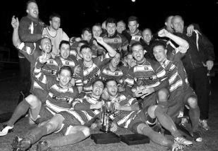
I also advised at the time of his 250 that his tally of goals placed him in 18th place on our goal scoring charts. Since that time he has bagged another fourteen, including Saturday’s header which moves him up to 13th position with 85 presently.

However, I class Dale as a midfielder more than a striker, albeit a very attacking one! If you agree with me, that means that he is the highest scoring midfielder in club history, as the players above him were all up front or on the wing for most of their appearances.

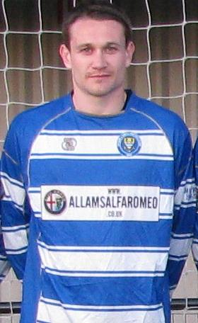
Now officially listed as a Club Legend, Dale has achieved many things and reached many milestones for the club, including of course a League Cup winner medal from May 2013. However, there are still a few more to aim for yet!

Dale is furthest right in the middle row of our May 2013 Cup winning team

Guildford City – History
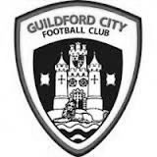
The first club in the town was amateur side Guildford FC, formed in 1877, and known as the “Pinks”. They played home matches at the Woodbridge Road Sports Ground. A successful start led to a number of people mooting a new professional club and by the end of 1920 Guildford United was formed. In May 1921 they were accepted into the Southern League, the equivalent of the Conference League today. At the same time land had been purchased in Joseph’s Road and “United” were able to kick-off the 1921-22 season with a home game against Reading Reserves. Playing in green and white the hosts won 2-0 with a crowd of over 5,000 spectators.

1927 saw the coming of Guildford as a Diocese and with it the building of a Cathedral. It was believed that Guildford would become a city so the Club changed its name and the “City” was born. At this time they also changed the colours to red and white stripes.

Although they had little early success in the League, the FA Cup bought a taste of glory in 1928-29 when, having battled through the qualifying rounds, they beat Queens Park Rangers 4-2 in the First Round Proper in front of a crowd of nearly 8,000. In the next round they were at home to Bournemouth but a similar crowd saw the visitors romp home 5-1.

Despite excellent gates and the highest League finish to date the Club was facing a financial crisis at the end of the season – this was to be a recurrent theme throughout the Club’s history. At the start of the 1936/37 season the Club made the massive decision to turn full-time professional, appointing Haydn Green as manager. That season they finished 4th but next season things got even better.

1937/38 saw victory over Reading in the FA Cup but in the League they won 22 of their 34 games to finish as Champions for the first time. That feat was nearly repeated the following year, with City finishing runners-up to Colchester United by 1 point, scoring 126 goals in the process. Indeed the League game at home to Colchester on Easter Monday saw City win 3-1 in front of the highest crowd ever for a League game at Joseph’s Road 9,443. Earlier that season City had attracted an even bigger crowd to Joseph’s Road for an FA Cup 1st Round Replay against local rivals Aldershot. 9,932 saw City lose a nail-biting game 4-3.

This successful period was brought to a premature conclusion by the outbreak of the Second World War. The ground had been used by the Army during the War and it wasn’t until 1946/47 that City re-entered the Southern League – this time as a part-time club. They again finished runners-up, this time to Gillingham but there followed 3 seasons of mediocrity. In 1950/51 the team finished 3rd in the League and reached the final of the Southern League Cup for the first time, losing to Merthyr Tydfil despite winning the first leg.

The 1951/52 season saw the longest trip ever undertaken by the City when they were drawn away to Gateshead in the 2nd Round of the FA Cup. An estimated 5,000 supporters made the overnight trip to the North East of England in December (there were no motorways in those days, and no heaters on coaches either!). A 15,000 crowd saw City dominate the game but lose 2-0. In debt again, City sold Jimmy Langley to Leeds for £2,000 – who eventually joined Fulham and earned three England international caps.

Archie Macaulay was brought in as player-manager in 1953 and he started building a side that would win the title in 1955/56. However, he left before the end of the season leaving Bill Thompson to take over and lead the side to the championship. In 1958/59 the League expanded and was regionalised. City were in the South Eastern zone and could only finish 15th out of 17.

For 1959 the League was revised again, this time to a Premier and First Division. City’s miserable time the year before meant they started in the lower division. Albert Tennant, who had been a coach at Chelsea, took charge and he led City to promotion. After a season of consolidation, the next four seasons saw finishes of 3rd, 4th, 4th and 2nd: on the last occasion only 2 points behind champions Weymouth. In the 1962/63 season they also lifted the Southern League Cup for the first time, beating Nuneaton Borough 2-1 on aggregate over two legs.

Despite this success by the summer of 1965 it seemed that finance was again a major problem at the Club. A strict budget left the club short of players, resulting in a disappointing 16th place finish, although they did manage to reach the final of the Southern League Cup again. They went on better the next year, winning the Southern League Cup with a 2-1 aggregate success over Barnet.

1967/68 saw a notable FA Cup run. Drawn away to Brentford the City were leading 2-1 when the match was abandoned during the second half because of snow. A second trip to Griffin Park ended with a 2-2 draw and meant a replay at Joseph’s Road in front of 7,500 fans who roared City to a famous 2-1 victory. Goalkeeper Peter Vasper was sold to Norwich City for £5000 and it was thought that this money and the money from the Cup games might ease the Club’s financial problems but they were worse than many had realised. The following season saw the end of Albert Tennant’s nine year reign and the Club was relegated.

In 1969/70 Joseph’s Road was sold to signal the beginning of the end for the Club. The following year they reached the second round of the FA Cup but the inevitable was only being delayed and although in 1972/73 the Club again reached the first round of the FA Cup (a visit to Watford ended with a 4-2 defeat), they could only finish 18th in the League. Crowds of 4,000 were needed to break even but barely a quarter of that was achieved at most games.

Guildford City Football Club Shock End Surrey Advertiser1973/74 saw a new board of directors in place with Bill Bellerby elected President (recently elected as Patron of the new club) and Club stalwart Darby Watts as player manager. Despite the best efforts of Mr Bellerby and the long standing Chairman of the Supporters’ Club John Daborn, it was soon announced that the Club was to merge with Dorking and play at Meadowbank. The final game at Joseph’s Road was played on 12th February 1974 when the City beat Folkestone 2-0 in front of 625 fans. After 53 years senior football at Joseph’s Road had come to an end.

In 1996 Bill Bellerby, then Mayor of Guildford, enquired as to whether Burpham FC would be prepared to move to the Spectrum Leisure Centre and represent Guildford. Spectrum provided a venue which had the potential for development into senior football and already had floodlighting.

Guildford City Football Club 2004 League ChampionsAFC Guildford played in the Surrey Premier League, which eventually became Division One of the Combined Counties League. In 2003/04 AFC Guildford were crowned champions of Division One and gained their first ever major honour.

Promotion was obtained into the Combined Counties Premier Division, ground-sharing with Cranleigh FC while Spectrum was upgraded to an acceptable standard. In early November 2004, AFC Guildford returned to their home ground near to the town centre.

In 2005 the club changed its name to Guildford United, but quickly acquired the name of Guildford City. The once famous name has returned to senior football after an absence of over 30 years.

Guildford City Football Club Combined Counties League Premier Division Champions2007/2008 brought a runner-up finish in the Combined Counties Premier League under Scott Steele and Lloyd Wye. Kevin Rayner, and his assistant Roly Martin, took charge in 2009.

After escaping relegation and undergoing a season of improvement, 2011/12 saw the club’s furthest progress in the FA Cup and Vase to date, but better was to come when the side clinched the Combined Counties Premier Division trophy. The success was bitter sweet however, as the club’s promotion was controversially denied due to Spectrum failing a ground grading inspection. Rayner’s side cantered to the league title once again the following year and this time were not denied the promotion they deserved – taking their place in the Southern League Division One Central.

Rayner’s side cantered to the league title once again the following year and this time took their place in the Southern League Division One Central. Having guided City to a ninth place finish in the new club’s inaugural Southern League season, Kevin Rayner departed the club to manage Chipstead. Guildford City were switched to the Southern League Division One South & West for the 2013/14 season, with former Sandhurst Town and Cove manager Dean Thomas taking the helm.

At the end of October and with the team struggling Thomas resigned his post to be replaced once again by Kevin Rayner. Sadly relegation could not be averted and 2014-15 sees Guildford City once again lining up in the Combined Counties League.

Ken Jones

The club would like to say thank you to our Physio, Ken Jones, who has announced that he is taking a break from football for a while.

Many of you will know that he has been with us as part of Lyndon’s backroom staff for a while.

What many of you won’t remember though, is that Ken was also doing his work at Epsom in the late eighties too, under the Management of Ricky Kidd and has also spent time at a number of other clubs, most notably at Sutton United and Carshalton Athletic.

It’s fair to say that he’s earned a rest!

Good luck Ken, we’ll see you soon hopefully.

New Physio required!
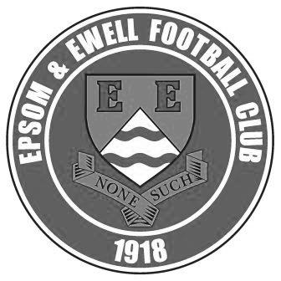
Epsom and Ewell FC are offering an exciting opportunity for a 3rd year student/graduate sports therapist to gain valuable experience at our club. Your role will include pre-game sports massage and taping (sports therapy if qualified) and pitch side first aid at both home and away games.

Games are on Saturday afternoons and mostly Tuesday evenings, both in Surrey and in neighbouring counties. The appropriate applicant will need to be able to commit to these sessions and preferably be able to get there independently. However, lifts can be arranged if necessary.

Experience of pitch side is welcome as well as working in a sports club environment. Applicants must have a valid first aid certificate and appropriate insurance. Expenses will be paid and are to be negotiated.

If interested please contact:

Peter Beddoe on 07767 078 132 or
Steve Dyke on 07582 725 073

First Eleven Appearances - (max 13 inc Spelthorne Sports)
Name | Debut | 2014/15 |  |  |  | Career Totals
Name | Debut | App | Sub | Total | Goals | App | Sub | Total | Goals
BROWN Oshane* | 30/08/2014 | 2 | 0 | 2 | 0 | 2 | 0 | 2 | 0
CURRIE Sam | 04/08/2012 | 2 | 0 | 2 | 0 | 96 | 5 | 101 | 2
DEAN Dan | 02/08/2014 | 11 | 0 | 11 | 0 | 11 | 0 | 11 | 0
DEWAR Ali | 29/10/2011 | 4 | 1 | 5 | 3 | 54 | 30 | 84 | 10
DOUGLIN Karl* | 03/08/2034 | 1 | 0 | 1 | 1 | 41 | 3 | 44 | 14
DOWNS Carl* | 17/09/2011 | 4 | 1 | 5 | 0 | 94 | 13 | 107 | 2
EACOTT Michael | 02/08/2014 | 11 | 0 | 11 | 0 | 11 | 0 | 11 | 0
FARRELL Matt | 02/08/2014 | 12 | 1 | 13 | 2 | 12 | 1 | 13 | 2
FERDINANDO Matthew | 20/09/2014 | 2 | 1 | 3 | 0 | 2 | 1 | 3 | 0
GAFFNEY Luke | 16/08/2014 | 4 | 1 | 5 | 0 | 4 | 1 | 5 | 0
HARPER Tommy | 15/04/2014 | 1 | 0 | 1 | 0 | 2 | 1 | 3 | 0
HAYWARD Ben | 07/03/2007 | 5 | 0 | 5 | 0 | 241 | 28 | 269 | 18
HOADLEY Harry | 15/04/2014 | 6 | 1 | 7 | 0 | 7 | 1 | 8 | 0
HOUGH Kyle | 14/08/2007 | 11 | 0 | 11 | 1 | 265 | 12 | 277 | 138
JARMAN Mark | 08/08/2009 | 1 | 4 | 5 | 0 | 132 | 50 | 182 | 76
MARVELL Dale | 15/01/2000 | 7 | 3 | 10 | 5 | 257 | 43 | 300 | 85
MURPHY George | 28/03/2013 | 8 | 1 | 9 | 0 | 49 | 5 | 54 | 2
MUTIMA Lionel | 05/08/2014 | 4 | 2 | 6 | 0 | 4 | 2 | 6 | 0
NELMES Elliott* | 05/08/2014 | 2 | 0 | 2 | 0 | 2 | 0 | 2 | 0
PANAYI Anthony | 14/11/2010 | 8 | 0 | 8 | 0 | 135 | 14 | 149 | 4
ROBINSON Sam | 22/10/11 | 8 | 1 | 9 | 3 | 32 | 4 | 36 | 8
SHAW Ollie | 20/09/2014 | 0 | 3 | 3 | 0 | 0 | 3 | 3 | 0
SMITH Taylor | 02/08/2014 | 11 | 0 | 11 | 5 | 11 | 0 | 11 | 5
TANTON Matt | 02/08/2014 | 7 | 2 | 9 | 1 | 7 | 2 | 9 | 1
TAYLOR James | 26/08/2013 | 8 | 1 | 9 | 1 | 25 | 7 | 32 | 2
VAN GELDER Julian | 12/09/2006 | 0 | 1 | 1 | 0 | 0 | 2 | 2 | 0
WHITE Sean | 02/08/2014 | 3 | 6 | 9 | 2 | 3 | 6 | 9 | 2
* Player has left the club

Centre page for results

Centre page for results

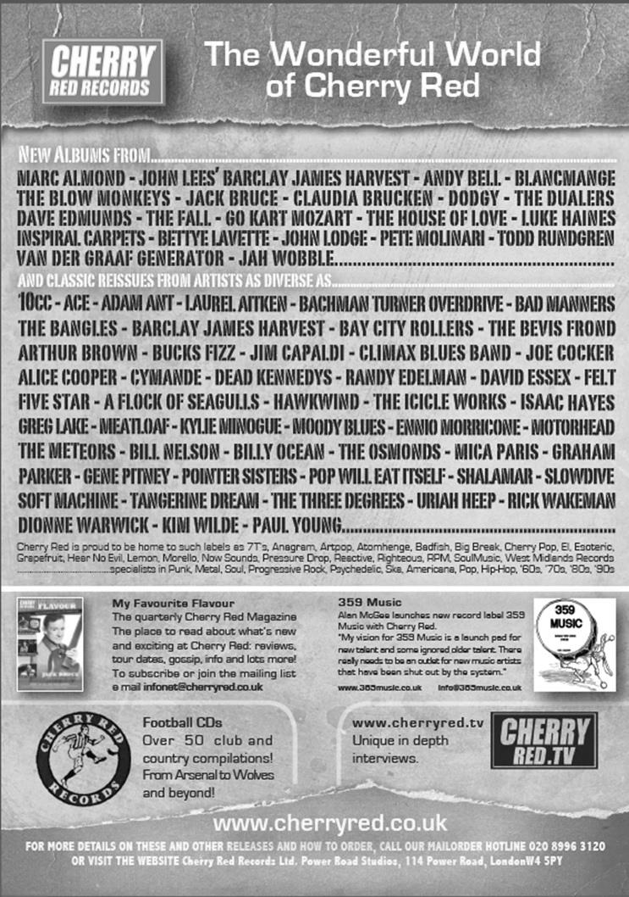

Match and Ball Sponsorships – 2014/15
Opponent | Date | Match Sponsor | Ball Sponsor
Raynes Park Vale | 05/08/14 | Club President - Stella Lamont
Horley Town | 25/08/14 | Epsom & Ewell F.C. Management Committee
Croydon (FAC) | 30/08/14 | Media Officer - Richard Lambert
Frimley Green | 13/09/14 | Dave Gaffney and friends
Guildford City | 30/09/14 | The Jarman family
Mole Valley SCR | 07/10/14 | Mark and Carmel Murphy
Bedfont Sports | 11/10/14 | Epsom & Ewell F.C. Colts
Knaphill (LC) | 14/10/14
Ashford Town (Mx) | 18/10/14
Chertsey Town | 28/10/14
F.A. Vase - 1st Round | 01/11/14 | If drawn at home
Spelthorne Sports | 11/11/14
Molesey | 22/11/14 | Provisional and dependent on Vase progress
Camberley Town (SSC) | 02/12/14 | Provisional date
Hanworth Villa | 06/12/14
Windsor | 03/01/15
Farnham Town | 17/01/15
Westfield | 31/01/15
Camberley Town | 07/02/15
Hartley Wintney | 21/02/15
Cove | 07/03/15
Badshot Lea | 21/03/15
Colliers Wood United | 04/04/15
Knaphill | 18/04/15
For League, League Cup and Surrey Senior Cup Matches:

Match sponsorship - £40.00 Match ball sponsorship - £25.00.
Combined Offer of Match and Match Ball sponsorship for £55.00.

For F.A. Cup and F.A. Vase matches:

Match sponsorship - £50.00 Match ball sponsorship - £30.00.
Combined Offer of Match and Match Ball sponsorship for £65.00.
----------------------------------------------------------------------------------------------------------------
Sponsorship includes

Admission, programmes, advertising (if required) and hospitality.

If you are interested, just speak to a Committee Member, you know where we are!
Alternatively, drop an email to richard.c.lambert@gmail.com

Above and Below
Ryman League Division One South Table
inc Wednesday 24th September | P | W | D | L | F | A | Pts | GD
Burgess Hill Town | 12 | 9 | 3 | 0 | 27 | 11 | 30 | +16
Corinthian-Casuals | 12 | 7 | 2 | 3 | 23 | 17 | 23 | +6
Faversham Town | 11 | 7 | 1 | 3 | 26 | 14 | 22 | +12
Whitstable Town | 11 | 5 | 5 | 1 | 23 | 16 | 20 | +7
Sittingbourne | 12 | 6 | 2 | 4 | 19 | 12 | 20 | +7
Whyteleafe | 11 | 5 | 4 | 2 | 22 | 13 | 19 | +9
Chipstead | 9 | 6 | 1 | 2 | 19 | 13 | 19 | +6
Guernsey | 13 | 5 | 3 | 5 | 31 | 24 | 18 | +7
Herne Bay | 12 | 5 | 2 | 5 | 17 | 16 | 17 | +1
Folkestone Invicta | 10 | 4 | 4 | 2 | 13 | 12 | 16 | +1
Tooting & Mitcham United | 11 | 4 | 3 | 4 | 18 | 12 | 15 | +6
Carshalton Athletic | 12 | 4 | 3 | 5 | 11 | 13 | 15 | -2
Merstham | 10 | 3 | 5 | 2 | 21 | 16 | 14 | +5
Worthing | 9 | 4 | 2 | 3 | 11 | 10 | 14 | +1
South Park | 11 | 4 | 2 | 5 | 18 | 21 | 14 | -3
Ramsgate | 11 | 4 | 1 | 6 | 11 | 15 | 13 | -4
Walton & Hersham | 12 | 4 | 1 | 7 | 13 | 21 | 13 | -8
Three Bridges | 12 | 3 | 4 | 5 | 16 | 31 | 13 | -15
Hastings United | 11 | 3 | 3 | 5 | 13 | 18 | 12 | -5
Redhill | 11 | 3 | 2 | 6 | 18 | 21 | 11 | -3
Horsham | 11 | 3 | 2 | 6 | 16 | 19 | 11 | -3
East Grinstead Town | 12 | 3 | 1 | 8 | 13 | 31 | 10 | -18
Hythe Town | 11 | 2 | 3 | 6 | 16 | 21 | 9 | -5
Walton Casuals | 11 | 1 | 1 | 9 | 9 | 27 | 4 | -18
As the League table starts to take shape, it is clear that Burgess Hill Town are running away with it. Having squeaked past Croydon 3-2 in the F.A. Cup they seem to be reserving their best work for the League and remain unbeaten.

Incredibly, Corinthian Casuals are just behind them. Having their best season for years, the Tolworth based club defeated Chipstead 3-1 in midweek and they may be the real deal this year as our landlords had made a fine start themselves.

My two favourites for the title, Folkestone and Carshalton Athletic have made very little headway thus far and both lost on Tuesday; 0-2 to East Grinstead Town and 1-4 to Whitstable Town respectively.

South Park too are finding it difficult, despite the addition of Jamie Hatfield and Nathan Ayling from our ranks. They defeated Three Bridges 3-1 in midweek though, so I am sure they will be fine.

At the bottom, Walton Casuals dispensed with their Manager last week and then won at Redhill! In midweek they drew 2-2 at Hythe Town but both of these opponents are not much better off. Still it’s a start as they try to avoid being cut adrift, but Saturday’s match at home to East Grinstead, played before this article went to print, was a big game for both clubs.

Above and Below
Combined Counties League Division One Table
inc Wednesday 24th September | P | W | D | L | F | A | Pts | GD
Worcester Park | 7 | 5 | 1 | 1 | 17 | 8 | 16 | +9
Banstead Athletic | 7 | 5 | 1 | 1 | 15 | 8 | 16 | +7
Farleigh Rovers | 8 | 5 | 1 | 2 | 18 | 12 | 16 | +6
AFC Croydon Athletic | 7 | 5 | 0 | 2 | 18 | 9 | 15 | +9
Bedfont & Feltham | 5 | 4 | 1 | 0 | 11 | 7 | 13 | +4
Cobham | 8 | 3 | 0 | 5 | 14 | 11 | 9 | +3
Ash United | 5 | 2 | 3 | 0 | 9 | 7 | 9 | +2
Alton Town | 6 | 2 | 2 | 2 | 13 | 12 | 8 | +1
Sheerwater | 7 | 2 | 2 | 3 | 11 | 12 | 8 | -1
CB Hounslow United | 7 | 2 | 2 | 3 | 7 | 10 | 8 | -3
Dorking | 7 | 2 | 0 | 5 | 11 | 18 | 6 | -7
Eversley & California | 7 | 2 | 0 | 5 | 10 | 19 | 6 | -9
Sandhurst Town | 8 | 2 | 0 | 6 | 15 | 27 | 6 | -12
Epsom Athletic | 7 | 1 | 2 | 4 | 14 | 20 | 5 | -6
Chessington & Hook United | 4 | 1 | 1 | 2 | 10 | 10 | 4 | 0
Staines Lammas | 4 | 1 | 0 | 3 | 5 | 8 | 3 | -3
Worcester Park continue to lead the way in the division below us, and registered a fine 3-1 win at Eversley & California on Saturday. Banstead and Farleigh also remain in the top three, although Farleigh slipped up 4-0 at Alton last weekend.

So below them, the bigger sharks are circling, waiting to make their move. AFC Croydon Athletic, soon to return to Mayfields Avenue edged Cobham out last week and I believe that the impetus of a new ground will help them (like I would know all about that!).

Additionally, Bedfont & Feltham and Ash United remain unbeaten while Alton are now just behind them. With no offence to the current top three, two of which face ground grading issues, I still feel certain that they will lose out to these better equipped clubs.

Lower down, Dorking look more competitive this term and I feel they will finish strongly as the season progresses and work at Meadowbank nears its conclusion.

Which brings me to the bottom three; I don’t imagine anybody saw any of these clubs in this position. Both Epsom Athletic and Staines Lammas had good seasons, just missing out on the top three last term, while Chessington & Hook are not a team I expected to see that far down, although it is still early days with only four matches played.

There are encouraging signs for all three. Lammas won 2-1 the week before last at Worcester Park, while Epsom Athletic now have Robbie Burns knocking them in alongside regular striker Wayne Cathcart. As for Chessington, they picked up over £3,000 for their Cup run, and with only 16 clubs in the division, they (and Epsom Athletic too) will not face the usual fixture backlogs caused by postponements at Chalky Lane. This division could be turned on its head by the end of the season!

From behind the goal
Westfield 4-0 Epsom & Ewell – Combined Counties League
Tuesday 23rd August 2014

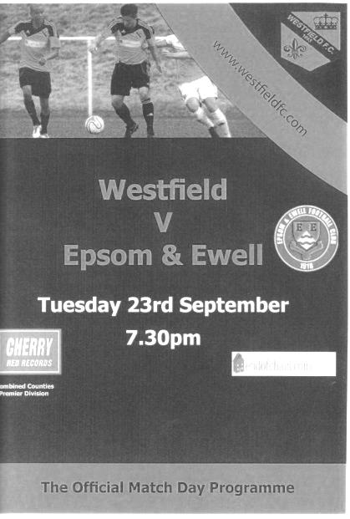
Back down to earth with a bump!

What a difference a few days can make in football! Only three days after we battered Knaphill, we found ourselves on the receiving end of a high tempo, hard-working performance ourselves and found that we were unable to do much about it.

Glyn made two changes from Saturday's win, both of which were by necessity as Mark Jarman and Taylor Smith were unavailable. In their places came the returning Kyle Hough and he was joined by Matthew Ferdinando who had made his debut at Knaphill. If you think that the results were different, try comparing Sean White's experience; the first which contained two goals was followed by an injury in the seventh minute that left him with suspected ankle ligament damage. He was replaced by Matt Tanton who found himself in the unusual position of left midfield as a result.

And this set the tone for the first half as we struggled to gain a foothold throughout the first half. There were sporadic attacks, but missing the pace of Smith we were unable to stretch them out and they closed us down at every opportunity. This bore fruit in the 26th minute when they broke through our defence, and although the original shot was well saved by Michael Eacott, the loose ball provided an easy tap in for their other player following in.

It was a deserved lead at that stage and although Dan Dean failed to get his header on target from a corner after 36 minutes, we created little and Eacott was the busier keeper. However, as we approached half time we started to make a bit of progress. Tanton had a shot deflected just wide before Hough had a low shot saved from close range.

We continued to attack in the second half and Matt Farrell had a shot deflected for a corner. As a result it was somewhat against the run of play

when the hosts scored a second after 54 minutes when a good free kick was glanced in, giving Eacott no chance. This was all about the delivery though and maybe we need to think about giving less free kicks away in the first place.

Farrell was unfortunate to see his header just dropping over the bar before another of his headers from a Tanton cross just feathered the crossbar on its way for a goal kick.

We then had a strange sequence of events in the 70th minute. Hough tried and failed to prevent a counter attack but the referee quite rightly played advantage, which Westfield then promptly wasted. We then broke and Farrell's cross was nearly palmed into his own net by the home keeper! Finally, at the first available opportunity, referee pulled Hough over and correctly booked him and it was an excellent example of the advantage rule, even though for some reason the home side still weren't happy!

The game became irretrievable in the 77th minute when a right wing cross was sent across the face of goal and it sounded as though it got a touch, but who from was hard to see. Either way, it found its way into the far corner. Six minutes later Westfield added a fourth when a similar ball across the area from the left was knocked in by an unmarked player at the far post. It was a frustrating night for our keeper, who did nothing wrong, yet conceded four!

As time expired we had our best two chances of the match. Firstly when Hough received the ball from Tanton, and he beat his man before beating the keeper with his shot, only to see the ball cleared off the line by a defender. Then from the ensuing corner Farrell headed the ball towards goal, only to see another defensive header on the line knock the ball up and out off the underside of the crossbar, with Hough's follow up header just over the bar.

In summary, we did create chances against a team that belied their league position, but defensively, we struggled to cope with them. This was partly because they outdid us in midfield where they were terrier-like, closing us down at every opportunity. Much like we did to Knaphill on Saturday in fact!

With a tough looking trip to Spelthorne Sports on Saturday coming up we will need to improve across the park or Eacott will have another busy day. In addition, it is hoped that some of our absent players will return shortly too as White joins our list of casualties.

Team: Michael Eacott, Lionel Mutima, Luke Gaffney, George Murphy, Dan Dean, Matthew Ferdinando, Sam Robinson, Matt Farrell, Dale Marvell, Kyle Hough, Sean White

Subs: Matthew Tanton for White (11), James Taylor for Mutima (67), Ollie Shaw for Ferdinando (78)

From behind the goal
Spelthorne Sports 0-3 Epsom & Ewell – Combined Counties League
Saturday 27th August 2014

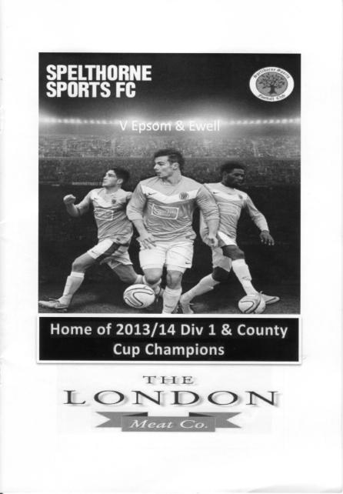
Marvell scores on his 300th as Salts surprise Spelthorne

So far under the "new Management" we have had a great win at Knaphill, while the Westfield game didn't go our way. However, the visit to Spelthorne provided an opportunity for our boys to show that this was a freak result.

The first bit of good news was that we had a full bench. Not only did Taylor Smith return to lead the line, but Anthony Panayi, Ali Dewar and more surprisingly, Sean White were all available. The return of White was most pleasing after he had appeared to badly injure his ankle at Westfield and I personally hadn't expected to see him back for a few weeks.

Spelthorne Sports completed the 2013/14 League season as unbeaten Champions and they had set a good pace in the rarefied atmosphere of the Premier Division with seven straight wins. However, a draw against Camberley, followed by their first loss in 39 matches to Colliers Wood United placed them in an unfamiliar situation and our boys took full advantage.

In fairness, it didn't look like it would be our day to start with. We created little in the opening twenty minutes while the home side, prompted by their chief threat Jesse Atiose gave young Luke Gaffney a tough test, although he only got through on a couple of occasions, and when he did, Michael Eacott was up to the challenge, blocking an early shot out for a corner after 8 minutes. We nearly conceded an own goal shortly afterwards when a Spelthorne free kick was flicked on by an unknown defender just a couple of feet beyond Eacott's left hand post.

However, we then went up the other end and earned a penalty after 27 minutes. Eventually that is. Smith had been clumsily bundled over and fell well inside the box and my first instinct was that it was a penalty. The Assistant thought so too, and ran to the goal line to position himself for the spot kick. The referee wasn't so sure though and decided to have a chat with his Assistant for a good minute before he finally decided to award the spot kick. After the delay you might have expected Kyle Hough to be a little nervous, especially as he hadn't yet scored this season and had missed from 12 yards against Frimley Green two weeks previously. If he was though, he didn't show it and waited for keeper Norman to go one way before dispatching the penalty in the opposite corner.

Smith nearly scored a second goal with a powerful shot that fizzed across goal and just

wide of the far post after 42 minutes but as we went off for half time it was noticeable that we were much more in the game than we had been earlier in terms of possession, although we had a scare right on the whistle when Gaffney sent a long back pass at pace towards Eacott. However, just feet away from his own goal line, he killed the ball with a nice bit of chest control and carried on as if nothing had happened. It would have been a most impressive strike from Gaffney if it had gone in the opposite direction!

The second half was only three minutes old when a deep Matt Farrell corner was met by a solid downward header from Dale Marvell, making his 300th appearance. The ball went down and as it bounced up it was tipped over the bar by Norman. However, the home side didn't heed the warning and with the clock by now showing the 49th minute Farrell did exactly the same thing with his next corner and Marvell met the ball at the back post, this time with a more conventional header and we were two nil up.

The game was becoming one of attack and counter attack. The home side pressed but frequently failed to find the target, shooting high and wide from distance. We had replaced Matthew Ferdinando with Matt Tanton in an attempt to close down the threat of Atiose, and this was a good move. Still the tricky winger broke through at times though and from one of these attacks Eacott was forced to react quickly to concede a corner.

Farrell was next to show with a good run into the right hand channel and he set up Hough who fired just over with his shot, while Smith couldn't make a decent contact after Sam Robinson had made tracks on the right and sent a low cross in. However, Smith was limping shortly after and was replaced by White. Marvell had another chance, but curled his shot just over the far corner of the goal before Eacott's only blemish when a corner slipped through his hands and required a defensive header off the line.

We were living dangerously at times, although so were they as we threatened to score whenever we went forward and our third goal after 83 minutes was from a classic counter attack. Hough ran fully forty yards across the park to reach a loose ball just in front of a defender and from his own half he set Farrell off down the left. He made a bee line for the goal and smashed the ball in and unfortunately for the home side, through the keeper Norman who will know that he should have kept it out.

Eacott made two more saves as time ticked down, one with his feet and another at full stretch, and this was his best game since our trip to Hartley Wintney. However, we looked irresistible once that first half hour had passed and by the end were deserving winners because we were clinical in front of goal, while the home side weren't!

Team: Michael Eacott, James Taylor, Luke Gaffney, George Murphy, Dan Dean, Matthew Ferdinando, Sam Robinson, Matt Farrell, Taylor Smith, Kyle Hough, Dale Marvell

Subs: Matthew Tanton for Ferdinando (HT), Sean White for Smith (68), Ollie Shaw for Gaffney (80)

Every Opponent A-Z
Over the years we have played many, many different opponents. Exactly how many is a difficult question, as it all depends on your definition. Are Camberley & Yorktown different to Camberley Town, or are Epsom Town different to Epsom F.C. or Epsom & Ewell F.C.?

In my analysis I have classed them as the same team, and will work through them all from A to Z. Some we have played many times, whilst others we have met maybe just once or twice. Enjoy!

Leyland Motors: Played 9 - W7 D0 L2 - F35 A8 - PPG - 2.33 - Fantastic


When I first found out that we had played Leyland Motors I saw that they played in Richmond Road and assumed that it must have been Kingstonian’s old ground. I was wrong, as the Hawker Centre, as it is now known, still exists, just up the road from the long departed K’s venue.

We first met the Motormen, a subsidiary of the main company based in Leyland, Lancashire, in December 1924 as members of the Surrey Senior League and we won both matches that season 2-1 at the Hawker Sports Ground and 3-1 at Horton Hospital Grounds. The following season we were destined to win the League for the first time, and we would only lose two matches in the process. However, both of our losses came against Leyland Motors, 0-1 on their first visit to West Street on 14th November 1925, and 2-0 in Kingston on 27th February 1926. We did have the benefit of a 6-0 win in the League Cup in January 1926 but ultimately the results made no difference as we won the League anyway but went out of the Cup!

At that point they left the Surrey Senior League, although we met in October 1926 in the Amateur Cup, winning 5-2 at the Hawker Sports Ground. Incredibly, the papers marked this down as a shock, because they had just recently beaten Mitcham Wanderers and Wimbledon in cup competition.

We defeated them easily in a friendly that season and then won 3-0 there in the Surrey Senior Cup during 1927/28 and that was that. Until 1946 that is when we drew them at home in the Amateur Cup, winning 9-0 at West Street.

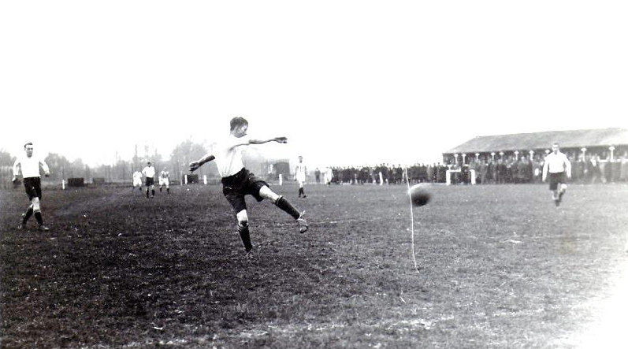

Reg Marlow scores one of our goals at Leyland Motors in the Amateur Cup in October 1926.
It is about the only picture I have from that era showing us in our away kit!

Leyton Orient / Clapton Orient: Played 2 - W0 D0 L2 - F3 A6 - PPG - 0.00

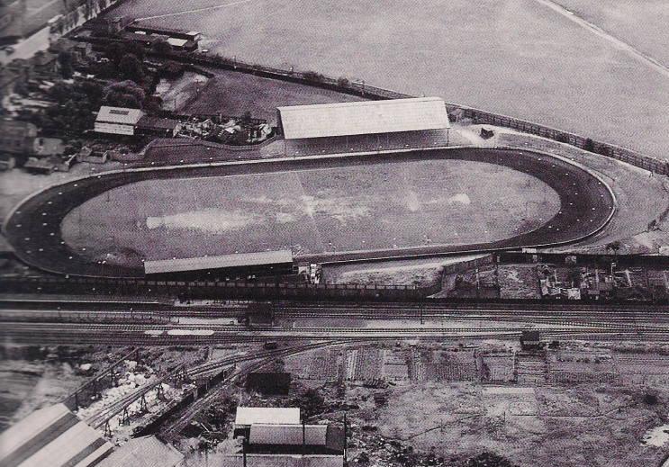
Most supporters will be aware of the fact that we met Clapton Orient in 1933 on our one and only appearance in the First Round of the F.A. Cup, narrowly losing 4-2 at the Lea Bridge Speedway Stadium (pictured) in front of 9.485 spectators.

What many will have forgotten is our visit to their current ground at Brisbane Road for a London Challenge Cup tie on 10th November 1992, losing narrowly 2-1. The Youth team also played there in the eighties, losing 4-0 in an F.A. Youth Cup First Round tie, but we have had very little other contact over the years.

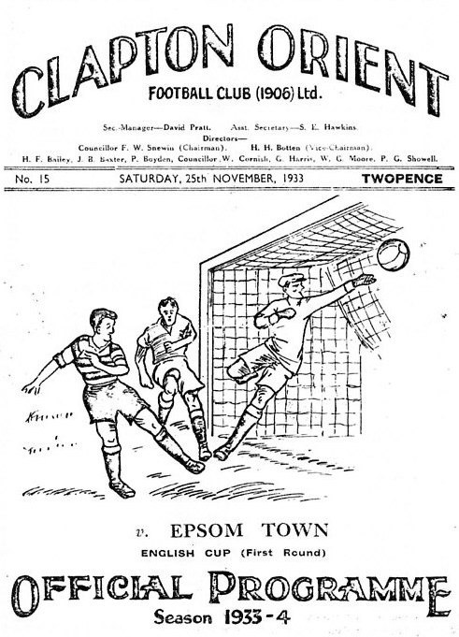
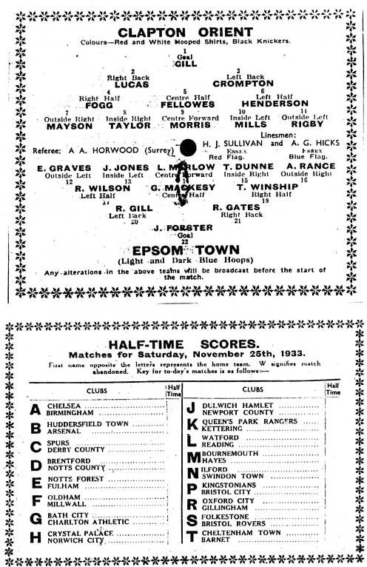
Maybe they would be an ideal team to play, when we get the chance to open a new ground!

In the meantime, here are some reminders of our famous day back in 1933.

Player Sponsorship
Here is the opening list of the season showing all of the players and Management available for sponsorship. Sponsorship costs £40 so if you want to help the club, the player and get your name in the programme for the season, just let us know.

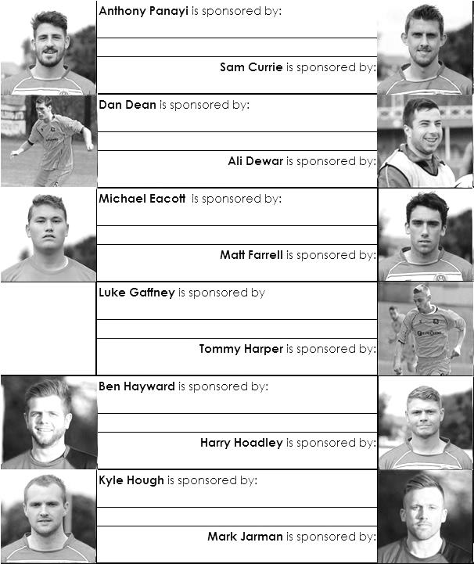

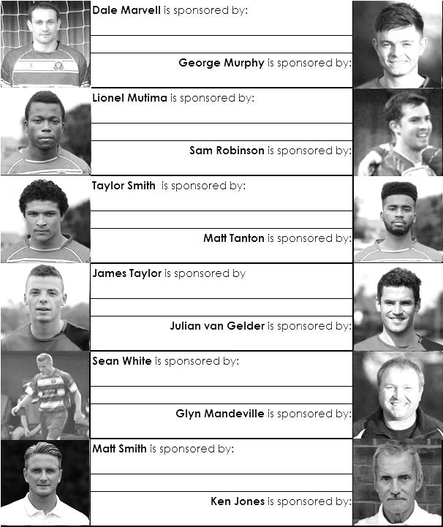

We are not fussy, we’ll take cash or a cheque! Any donation will help the club and is much appreciated.

EL Records Premier Challenge Cup
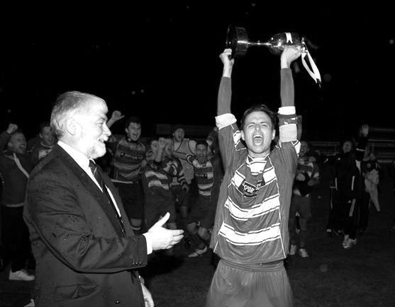
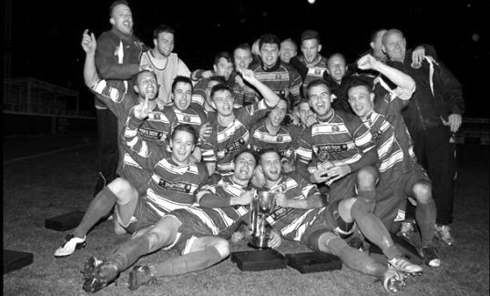
First Round
Raynes Park Vale | 0-5+ | Spelthorne Sports
Bedfont Sports | 3-1 | Staines Lammas
Chertsey Town | 1/10 | Hartley Wintney
Frimley Green | 2-1+ | AFC Croydon Athletic
Sandhurst Town | 1-5 | Horley Town
Second Round
Alton Town | 14/10 | Farnham Town
Eversley & California | 21/10 | Ash United
Cobham | 14/10 | Horley Town
Frimley Green | 14/10 | Spelthorne Sports
Bedfont Sports | 14/10 | Cove
Westfield | 14/10 | Farleigh Rovers
Ashford Town (Mx) | 30/9 | CB Hounslow United
Colliers Wood United | 1/10 | Bedfont & Feltham
Worcester Park | V | Chessington & Hook United
Sheerwater | 11/10 | Mole Valley SCR
Badshot Lea | 14/10 | Dorking
Chertsey Town /  Hartley Wintney | 14/10 or 15/10 | Windsor
Epsom & Ewell | 14/10 | Knaphill
Camberley Town | 14/10 | Molesey
Epsom Athletic | 15/10 | Banstead Athletic
Hanworth Villa | 14/10 | Guildford City
Surrey Senior Cup
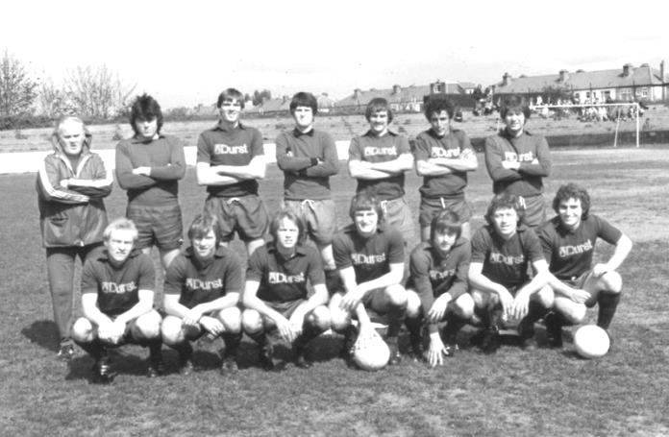
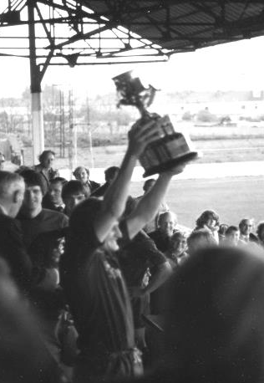
First Round
Carshalton Athletic | 21/10 | Egham Town
Croydon | V | Colliers Wood United
Merstham | 21/10 | Whyteleafe
Raynes Park Vale | V | Chertsey Town
South Park | 21/10 | Guildford City
Second Round
Lingfield | V | Westfield
Redhill | V | Raynes Park Vale /  Chertsey Town
AFC Wimbledon | V | Chipstead
Godalming Town | 11/11 | Mole Valley SCR
Knaphill | V | Croydon /  Colliers Wood United
Metropolitan Police | V | Walton & Hersham
Epsom & Ewell | V | Camberley Town
Leatherhead | 26/11 | Farnham Town
Merstham / Whyteleafe | V | Beckenham Town
Molesey | V | Carshalton Athletic /  Egham Town
South Park / Guildford City | V | Sutton United
Walton Casuals | V | Corinthian Casuals
Badshot Lea | V | Kingstonian
Dorking Wanderers | V | Frimley Green
Tooting & Mitcham United | V | Horley Town
Woking | V | Ashford Town (Mx)
F.A. Vase
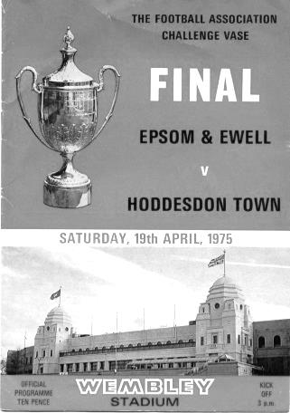
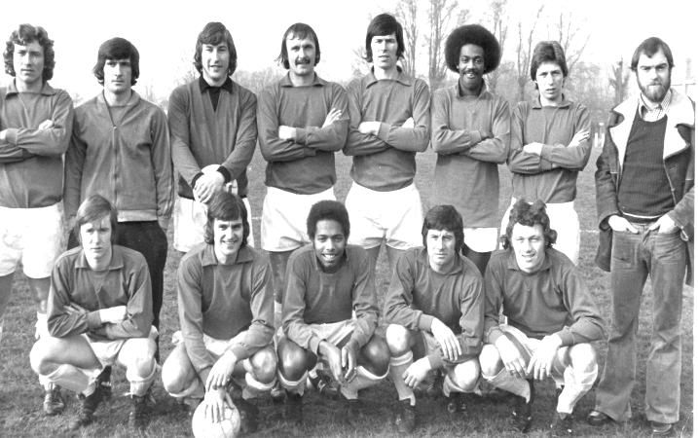
First Qualifying Round – 6th September
Cove | 2-3 | Wootton Bassett Town
Hartley Wintney | 3-2 | Holyport
Holmesdale | 4-5+ | Colliers Wood United
Horley Town | 3-2 | Sevenoaks Town
Lancing | 4-1 | Mole Valley SCR
Langford | 2-2+ replay 1-4 | Spelthorne Sports
Raynes Park Vale | 2-1 | Crowborough Athletic
Windsor | 3-0 | Shrivenham
Woodley Town | 3-0 | Badshot Lea
First Qualifying Round replay – 9th September
Spelthorne Sports | 4-1 | Langford
Second Qualifying Round – 4th October
Colliers Wood United | V | Shoreham
Cray Valley (PM) | V | Horley Town
Farnham Town | V | Milton United
Flackwell Heath | V | Frimley Green
Highworth Town | V | Hartley Wintney
Spelthorne Sports | V | Risborough Rangers
Molesey | V | Greenwich Borough
Raynes Park Vale | V | Epsom Athletic
Rothwell Corinthians | V | Bedfont Sports
Windsor | V | Binfield
Woodley Town | V | Knaphill
Exempted Clubs (Draw for First Round is on Monday 6th October)
Ashford Town (Mx) – 1st Round |  | Guildford City – 1st Round
Camberley Town – 1st Round |  | Westfield – 1st Round
Chertsey Town – 1st Round
Epsom & Ewell – 1st Round |  | Hanworth Villa – 2nd Round

Photo of the Week
This week’s photo from Gemma Jarman shows a bit of a gathering. Following our fourth goal at Knaphill, the players clearly wanted to get our Manager in on the celebrations!
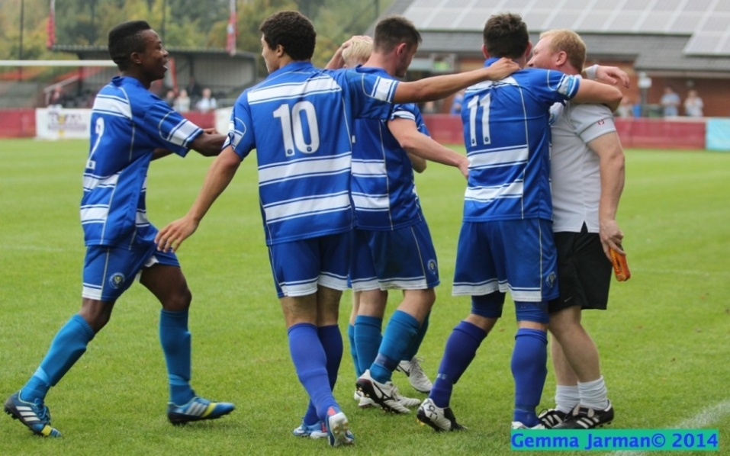

Many more of Gemma’s photos from almost every Salts game played in the last five years are available on our website: Why not have a look?

Anthony Panayi – 150 Appearances
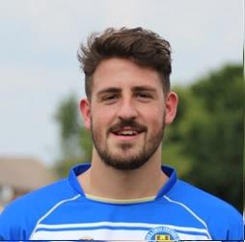
Congratulations go to Anthony Panayi, who if selected will make his 150th appearance tonight.

I can confirm from my ancestral club research that Anthony would be the second youngest player in club history to have reached this mark, having made his debut in our F.A. Vase tie at home to Bracknell Town on 14th November 2010 at Merstham.

The youngest player to reach the mark was Tommy Tuite who was 21 and 330 days while Anthony is 21 and 358 days as you read this and that is 62 days younger than the third player on our list, Barry Stevens. Still that’s fairly good company to be associated with, as Tommy was of course a legend for this club, and remains our record goalscorer with 391, while Barry went on to much success with Carshalton Athletic.

Anthony has also been carrying out Captaincy duties while Club Captain Sam Currie recovers from injury, so there’s quite a lot of responsibility on the young man’s shoulders, even if he is now one of the oldest players at the club, being almost 22 years old. #ancient

Nice one Ant. Plenty of time for many more!

Combined Counties League – Premier Division
Tuesday, 30th September 2014 - Kick-off 7.45 p.m.
Epsom and Ewell  (Royal Blue & White hoops) | V |  | Guildford City  (Red and White Stripes)
 | NUMBERS
Michael Eacott |  |  | Antony Hall
James Taylor |  |  | Bruce McPhail
Matt Tanton |  |  | Liam Talbot
© George Murphy |  |  | Liam Harwood
Dan Dean |  |  | Ray Guilford
Ben Hayward |  |  | Ben Rayner ©
Matt Farrell |  |  | Anthony Baker
Dale Marvell |  |  | Jack Guilford
Taylor Smith |  |  | Stefan Joseph
Kyle Hough |  |  | Khari Oriogun
Sam Robinson |  |  | Jordan Taylor
Mark Jarman |  |  | Sam Spencer
Lionel Mutima |  |  | Junior Alade
Luke Gaffney |  |  | George Baldwin
Ollie Shaw |  |  | Ryan Wallis
Anthony Panayi |  |  | Navid Zandi
Matthew Ferdinando
Ali Dewar
Glyn Mandeville | MANAGER |  | Kevin Rayner
Matt Smith | ASSISTANT
Matt Smith | COACH |  | Rowen Martin
Tony Coombe | CHIEF SCOUT
Steve Eacott | GOALKEEPING COACH
REFEREE: A.Desai (Tolworth)
ASSISTANTS: M.Stevens (Morden), F.Collins (Beckenham)
Today’s Match and Match Ball are sponsored
by regular supporters the Jarman family

OUR NEXT VISITORS TO HIGH ROAD

Mole Valley SCR

Tuesday 7th October 2014 - Kick-off 7.45 p.m.
Combined Counties League – Premier Division

